314 Reviewer PRELIM
Data
- referred to facts concerning objects and events that could be recorded and stored on computer media.
- raw but not complete.
Information
- when data was processed.
- it is detailed.
Metadata
- is data about data through which the end-user data are integrated and managed.
Database
- is an organized collection of logically related data.
- store data or storage.
DBMS – is a software that allows creation, definition, and manipulation of database, allowing users to store, process and analyze data easily.
- also provides protection and security to the databases.
CHARACTERISTICS OF DBMS
- Data stored into Tables <- columns and rows
- Reduced Redundancy -> limit iteration
- Data Consistency -> doesn’t change
- Support multiple user and Concurrent Access
- Query Language
- Security
COMPONENTS OF DBMS
- Hardware
- Software
- Data
- Procedures
- Database Access Language
DATABASE ARCHITECTURE
- 1-tier DBMS – when the database is directly available to the user for using it to store data.
- 2-tier DBMS – includes an application layer between the user and the DBMS, which is responsible to communicate the user’s request to the database management system and then send response from the DBMS to the user.
- 3-tier DBMS – is the most used architecture for web applications.
DATABASE MODEL
- Defines the logical design and structure of a database.
- Defines how data will be stored, accessed, and updated in a database management system.
RELATIONAL MODEL
- Is the most widely used database model.

History of Relational Model
- It is introduced by Ted Codd in 1970.
- Uses concept of mathematical relation.
- First commercial implementations of the relational model:
- Oracle DBMS
- SQL/DS System (IBM)
More databases…
- PhpMyAdmin
- MySQL Workbench
- MongoDB
- Firebase
- Popular RDBMSs:
- SQL Server & Access (Microsoft)
- DB2 & Infomix (IBM)
- Standard for commercial RDBMS:
- SQL query language
Terms and Meaning:
- IBM – International Business Machines
- DBMS – Database Management System
- RDBMS – Relational Database Management System
- SQL – Structured Query Language

Terminologies
- Relational Model represents data as a collection of tables.
- A table is also called a relation.
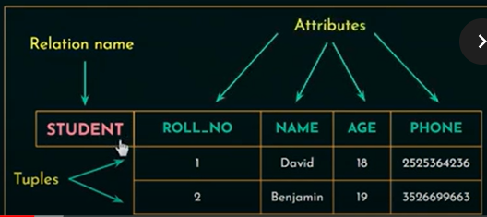
- Each row is a tuple.
- Column headers are attributes.

- Domain:
- A set of atomic values allowed for an attribute.
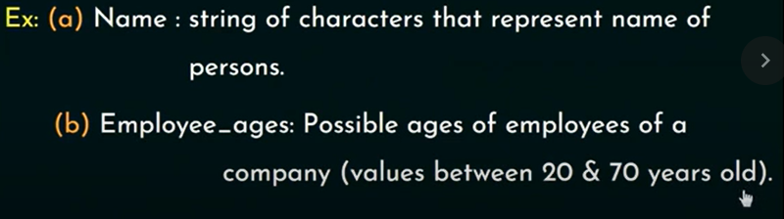
- Relation Schema:
- Describes a relation.
- Made up of a relation name R and a list of attributes $A_{1}$,$A_{2}$,$A_{3},…,A_{n}$.
- Degree (or Arity) of a relation:
- Number of attributes in a relation schema.
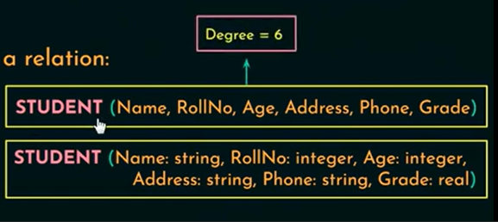
- Cardinality:
- Total number of tuples present in a relation.
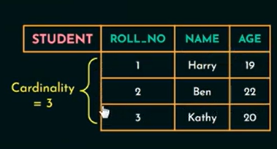
- Relational state (or relation instance):
- Set of tuples at a given time.

Terminologies
- Entity
- A “thing” in the real world with an independent existence.
- May be an object with physical existence (ex. House, person) or with a conceptual existence (ex. course, job).
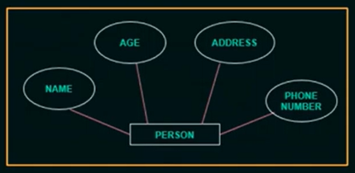
- Attributes:
- Properties that describe the entities.

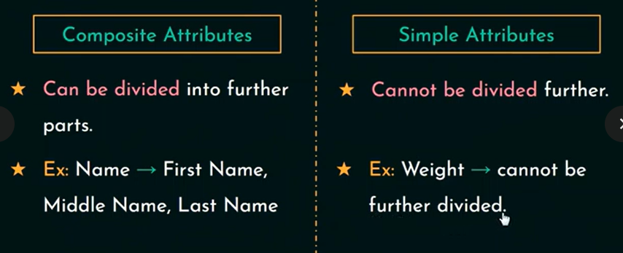

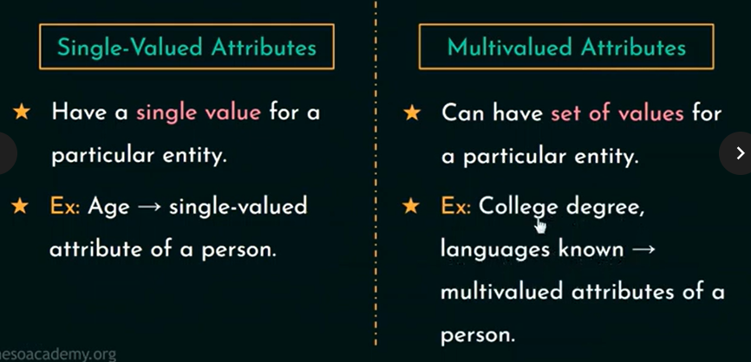

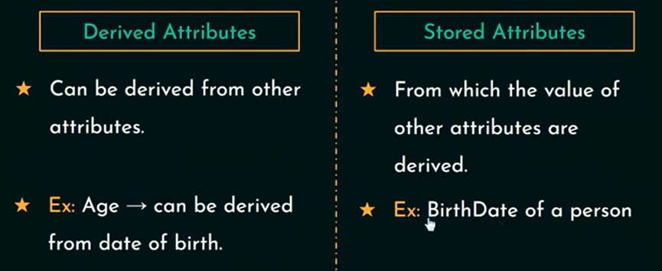

- Complex Attributes:
- Has multivalued & composite components in it.
- Multivalued attributes – represented within ‘{ }’.
- Composite attributes – represented within ‘( )’.
- Ex. {CollegeDegrees(College, Year, Degree, Field)}
- Null Values:
- Null is something which is not applicable or unknown.
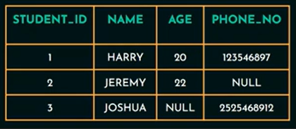
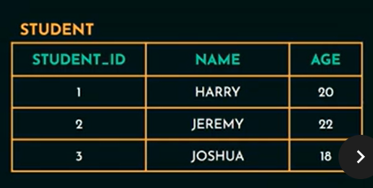
- Entity Type:
- A collection of entities that have the same attributes.
- Ex. STUDENT
- Entity Set:
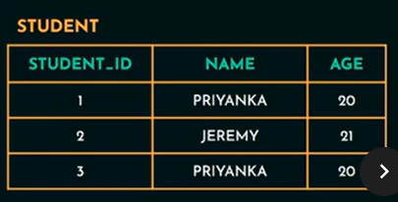
- That attribute that is capable of identifying each entity uniquely.
- Ex. Roll number of a student
- Value Set of Attributes:
- The set of values that can be assigned to an attribute.

ENTITY RELATIONAL MODEL (ERD)
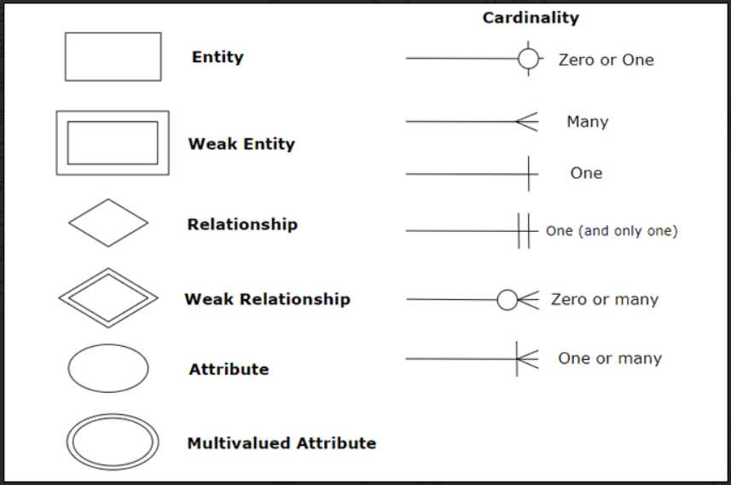

ENTITY-RELATIONSHIP (ER) DIAGRAMS

- Depicts entities, the relationships between them and attributes of those entities and relationships.

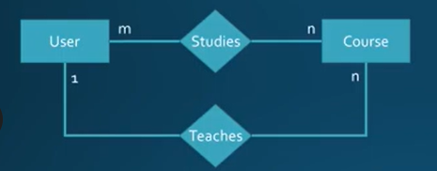
Types of CARDINALITY:
- One-to-one
- One-to-many
- Many-to-many

Cardinality Rules of Thumb:
- Can a user study multiple courses, or only one?
- Multiple: ‘n’ next to course
- Only one: ‘1’ next to course
- Can a course be studied by multiple users, or only one?
- Multiple: ‘m’ next to user
- Only one: ‘1’ next to user
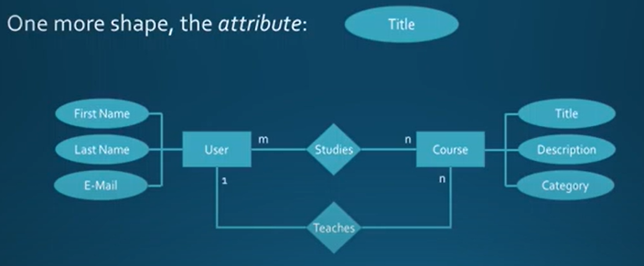

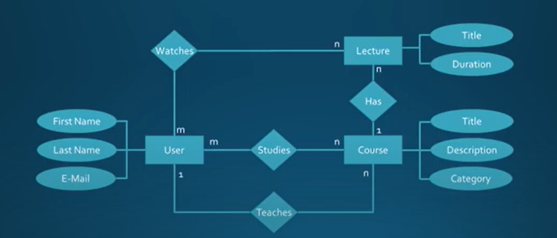

What is PRIMARY KEY?
- The primary key (PK) is a column or set of columns that uniquely identifies each row in the table.
- A table can have only one Primary Key, which can be made up of one or more fields.
- The primary key must contain unique values, should not be null and should never change.
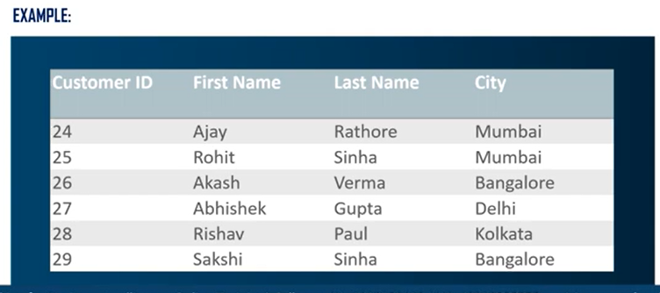

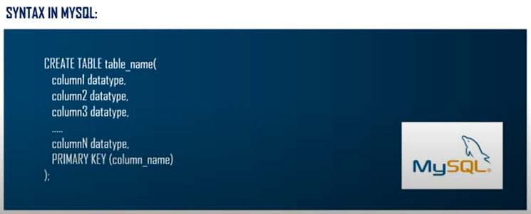

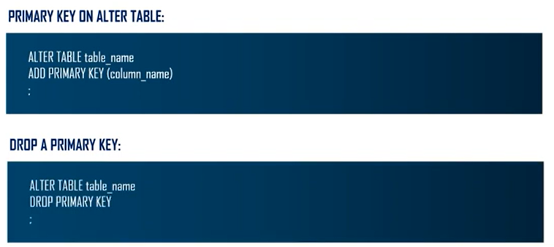

What is FOREIGN KEY?
- The foreign key is a column or set of columns that is used to links two tables together.
- The foreign key of one table helps to connect with the primary key of another table.
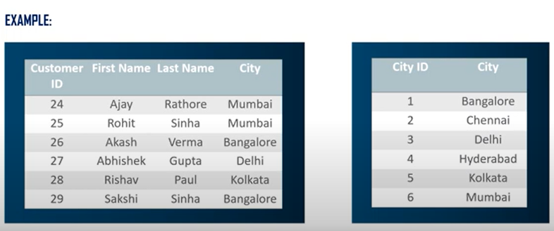
- Foreign key is used to create links between tables.

